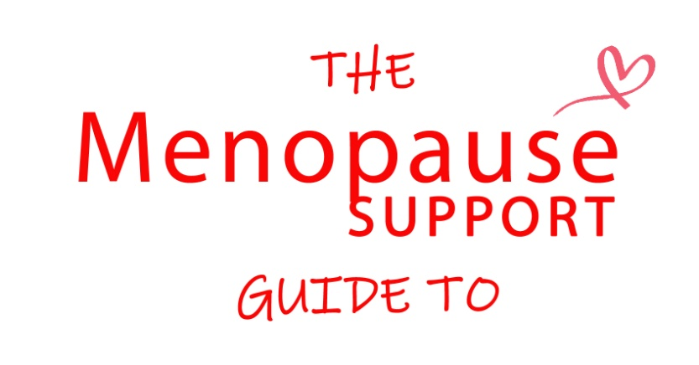
10 Things Your Doctor Should Know About Menopause
Every day of every week I counsel women experiencing menopause symptoms and every single day women tell me that they are being incorrectly refused or denied access to treatment due to a lack of GP education in menopause. In recent weeks I have spoken to women who have been told they are depressed or stressed and need anti depressants, that they are either too young or too old to be experiencing menopause symptoms or that they need to wait until their symptoms are worse or they have experienced twelve months without a period before treatment can be discussed.
During the last few years in my work supporting women through the menopause and beyond it has become clear that education for health care professionals on the subject of menopause is poor and sometimes nonexistent and many GP’s, often the first port of call, are simply not equipped to help, not the fault of the individual GP but that of those who set the curriculum for their training and the CCG’s throughout the country who do not demand compliance with the recommendations in the clinical guidelines published in November 2015.

Women, their partners and their families cannot afford to keep waiting for GP education to improve; too many women are experiencing poor short and long term physical and mental health due to a woeful lack of professional knowledge. Having campaigned now for several years for better care and support for women it is clear that things are not changing quickly enough so we must take control and educate ourselves and encourage others to do the same. To that end I have compiled a list of

10 things your doctor should know about Menopause

- The NICE guidelines on Menopause were published for health care professionals in November 2015; your GP should have knowledge of and apply the recommendations in the guidelines to their practice. Don’t be afraid to ask your GP if they have read them as many haven’t and many others are not even aware of them.
- The average age of menopause is 51 but for many women the symptoms of peri menopause start in their early forties. Blood hormone tests for women over the age of 45 are not appropriate and menopause should be diagnosed on symptoms. Periods do not need to have changed to indicate peri menopause, women do not need to have stopped having periods to enable them to have HRT.
- Premature menopause affects one in a hundred women under the age of forty, one in a thousand women under thirty and one in ten thousand under twenty. It is very important that women in premature menopause are counselled about the importance of hormone replacement therapy (where appropriate) to protect their long term health.
- Surgical menopause affects women who have had their ovaries removed, sometimes in conjunction with their womb. These women must receive hormone replacement therapy (where appropriate) to protect their long term health.
- Common physical symptoms include; palpitations, feeling tired or lacking energy, feeling dizzy or faint, headaches, joint pain, itchy skin, hair loss, vaginal dryness, increased urinary tract infections and loss of libido.
- Menopause symptoms are not just hot flushes, night sweats and changing periods. Many women experience mental and emotional symptoms before any physical symptoms, these can include; anxiety, panic, low mood, difficulty concentrating and a loss of confidence.
- Hormone Replacement Therapy, not anti depressants is the first line treatment for menopause. Far too many women are being diagnosed as stressed or depressed and prescribed anti depressants when they are in fact peri menopausal. Women who choose not to or are not recommended to use HRT should be counselled on alternative treatment choices.
- Body identical hormone replacement therapy is available via the NHS. I speak to so many women who tell me that their Dr has told them it’s not. The majority of oestrogen called estradiol available in the UK is body identical; most GP’s can also prescribe micronized body identical progesterone. There is no time limit on how long a woman can use HRT.
- Women who still have their womb must be prescribed oestrogen and progesterone to protect the womb lining. I have counselled several women in the past few months that have been prescribed oestrogen only; this is incorrect and potentially dangerous.
- Women in medical menopause due to a cancer diagnosis or who present with complex medical histories should be referred to an NHS menopause specialist clinic for consultation and treatment options.

How you can prepare for your appointment?

- Do your research; take a look at the NICE guidelines, knowledge is power.
- Make a list of all your symptoms and anything you have used to try to alleviate them.
- Take a trusted friend or family member with you; it can be great to have support.
- Make a list of your questions; it’s easy to forget once you sit down with the doctor.
- Be prepared to wait for answers; if your doctor is unsure ask him or her to consult a colleague or read the NICE guidelines before coming back to you.

I truly hope that you will not need this list and that you will be fortunate enough to see a doctor or practice nurse who has taken a particular interest in women’s health and has furthered their studies in menopause. However if that’s not the case I hope this will prove to be useful for you, your family and your friends and if you need to don’t hesitate to print it off and take it with you to your appointment. Good Luck x

Diane Danzebrink (dianedanzebrink.com) is The Menopause Counsellor a Psychotherapist with professional nurse training in Menopause; she is a member of the British Menopause Society and the founder of menopausesupport.co.uk and the #MakeMenopauseMatter campaign.

